Place
Student’s Picture
Here
SEVERE ALLERGY ACTION PLAN
FOR SCHOOL PERSONNEL

Student: _________________________ Grade: ______ DOB: ____________________
Teacher: _________________________ Classroom: ________School Year: _____

SEVERE ALLERGY TO: _________________________________________________

Asthmatic: YES □* NO□ * Higher risk for severe reaction

STEP 1: RECOGNIZE THE SYMPTOMS

If __________________________ shows the following symptoms as check by doctor:

Symptoms: (Doctor, please select by checking all symptoms that require Epinephrine Auto-Injector administration)

□ Mouth itching, tingling or swelling of the lips, tongue, mouth
□ Throat tightening of throat, hoarseness, hacking cough
□ Skin hives, itchy rash, swelling of the face or extremities
□ Gut nausea, abdominal cramps, vomiting, and diarrhea
□ Lung shortness of breath, repetitive coughing, wheezing
o Heart weak or thready pulse, low blood pressure, fainting, pale, blueness
o Other _____________________________________________________________

STEP 2: RESPOND

Give Epinephrine Auto-Injector as directed per Authorization for Medication Form.

(Doctor, please select by checking dosage to be administered)

□ Epinephrine Auto-Injector (0.15mg epinephrine)
OR
□ Epinephrine Auto-Injector (0.3mg epinephrine)

Administer rescue breathing or CPR, if necessary.

STEP 3: EMERGENCY CALLS

1. Call 911
2. Call Emergency Contacts:

Name/Relationship | Phone Number | Alternate Phone Number
1. | 1. | 1.
2. | 2. | 2.
3. | 3. | 3.

_______________________________________ ____________________________________
Doctor Signature Date Parent/Guardian Signature Date

SEVERE ALLERGY ACTION PLAN
FOR SCHOOL PERSONNEL

Student: ___________________________ DOB: ____________
Teacher: ___________________________Classroom: ______ Grade: ____

SEVERE ALLERGY TO: _________________

Auvi-Q Epinephrine Auto-Injector Trained Staff:

Name (Please print) | Title | Signature

Nurse Verification:
Action plan and staff training verified.

Nurse signature _______________________________ Date_________________________

Parent/guardian signature ______________________ Date _________________________

Directions for Auvi-Q (Epinephrine) Auto-Injector 0.15mg or 0.3mg
- Pull Auvi-Q from the outer case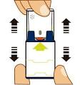and follow the voice instructions
(do not proceed to step 2 until you are ready to use Auvi-Q. If not ready to use, replace the outer case.)
- Pull off Red safety guard (The safety guard is meant to be tight. Pull firmly to remove.)
- Place black end against the middle of the outer thigh (through clothing, if necessary), then press firmly
- and hold in place for 5 seconds
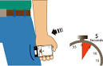
- Note: Auvi-Q makes a distinct sound (click and hiss) when activated. This is normal and indicates Auvi-Q is working correctly.
- Call 911 or seek emergency medical attention.
- Deliver used Auvi-Q Epinephrine Auto-Injector to EMS responders.

SEVERE ALLERGY ACTION PLAN

Place
Student’s Picture

FOR SCHOOL PERSONNEL

Student: ___________________________ DOB: ____________
Teacher: ___________________________Classroom: ______ Grade: ____

SEVERE ALLERGY TO: _________________

Adrenaclick Epinephrine Auto-Injector Trained Staff:

Name (Please print) | Title | Signature

Nurse Verification:
Action plan and staff training verified.

Nurse signature _______________________________ Date_________________________

Parent/guardian signature ______________________ Date _________________________

Directions for Adrenaclick (Epinephrine) Auto-Injector 0.15mg or 0.3mg
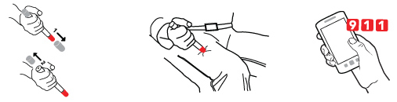

ADRENACLICK®/ADRENACLICK® GENERIC DIRECTIONS
1. Remove the outer case.
2. Remove grey caps labeled “1” and “2”.
3. Place red rounded tip against mid-outer thigh.
4. Press down hard until needle penetrates.
5. Hold for 10 seconds. Remove from thigh.
6. Call 911 or seek emergency medical attention.

7. Deliver used Adrenaclick Epinephrine Auto-Injector to EMS responders.

SEVERE ALLERGY ACTION PLAN
FOR SCHOOL PERSONNEL

Student: ___________________________ DOB: ____________
Teacher: ___________________________Classroom: ________ Grade: ______

SEVERE ALLERGY TO: _________________

EpiPen Trained Staff:

Name (Please print) | Title | Signature

Nurse Verification:
Action plan and staff training verified.

Nurse signature _______________________________ Date_________________________

Parent/guardian signature ______________________ Date _________________________

____________________________________________________________________________

Directions for EpiPen (Epinephrine) Auto-Injector 0.15mg or 0.3mg

- First, remove the EpiPen Auto-Injector from the plastic carrying case

- Pull off blue safety release cap.

- Hold the orange tip near outer thigh (always apply to thigh)

- Swing and firmly push orange tip against outer thigh so it clicks.
Hold on thigh for 10 seconds.

- Remove the EpiPen Auto-Injector and massage the area for 10 seconds.

- Deliver used EpiPen to EMS responders. 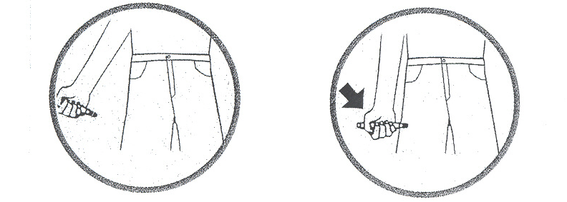
Test Your Knowledge

- What is an Epinephrine Auto-Injector?

- When and why is the Epinephrine Auto-Injector given?

- Into which part of the body should the Epinephrine Auto-Injector be injected?

- Can an Epinephrine Auto-Injector be administered through clothing?

- How long should you hold the Epinephrine Auto-Injector in place to ensure the medicine has been given?

- If applicable, how many doses of epinephrine (0.15mg or 0.3mg) are in one Auto-Injector?

- What emergency calls will be made?

- Where will the student be transported to?

The 3 Rs:
REVIEW the severe allergy action plan
RECOGNIZE the symptoms
RESPOND per the severe allergy action plan

Resources:
auvi-q.com/hcp/watch-demo
auvi-q.com/hcp/mobile-app
www.foodallergy.org
www.aaaai.org

Epinephrine Auto-Injector Meeting Sign-in Sheet
DOH-Miami-Dade School Health Program

Meeting: | Date:
Name (Please Print) | Title
1
2
3
4
5
6
7
8
9
10
11
12
13
14
15
16
17
18
19
20
21
22
23
24
25
26

