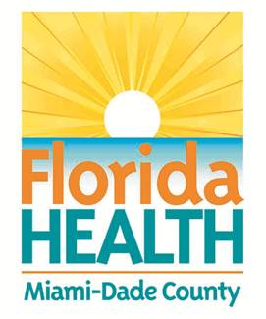
Florida Department of Health in Miami-Dade County
School Health Program
Health History and Consent: Diabetes

Student: _______________________________________________________ DOB: _______________ Grade: ______
School: _______________________________ School Year: ______________Teacher: _______________________
Parent/Guardian Name & Phone: _____________________________________________________________________
KNOWN ALLERGIES: ____________________________________________________________________________

Dear Parent/Guardian:
School records or medical information indicates your child has diabetes. In order to attend to your child’s health and safety, the school requires a health history. Please return this form to the nurse as soon as possible. It will become part of your child’s confidential school health record. Our primary concern is that your child’s healthcare needs are met while in school.
__________________________ __________________________________ _________________
School Nurse Phone number Date

- When did your child last see a doctor related to this condition? __________________________________

- Has your child ever been hospitalized for diabetes?  Yes  No
If yes, when? ______________________

- Has your child ever experienced diabetic coma or insulin reaction?  Yes  No
If yes, when? ______________________

- Please list all medications your child takes below.
Name of Medication Dosage Time Given How often?

- ________________________________________________________________________________
- ________________________________________________________________________________
- ________________________________________________________________________________

- Please check (☑) ‘Yes’ or ‘No’ to answer whether your child knows:
▪ How to check his/her own blood sugar?  Yes  No
▪ How to draw up correct dose of insulin?  Yes  No
▪ How to give his/her own injection?  Yes  No
▪ What type of insulin is prescribed?  Yes  No
▪ When medication should be given?  Yes  No
▪ To report signs and symptoms of hyper/hypoglycemia?  Yes  No

- Additional comments: ___________________________________________________________________________
____________________________________________________________________________________________________________________________________________________________________________________
CONSENT:

Please circle your response and sign:(I do /I do not) give the school Nurse my permission to share information relevant to my child’s medical status with school staff on a “need to know” basis, if she/he determines that this information is necessary to assure my child’s health and safety.

Parent/Guardian Signature: ___________________________________________________________ Date: __________

