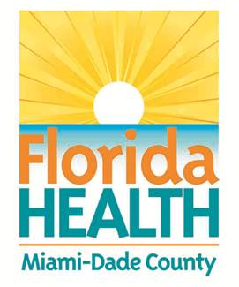
Florida Department of Health in Miami-Dade County
School Health Program
Health History and Consent: Attention Deficit Disorder/Attention Deficit Hyperactivity Disorder

Student: _________________________________ DOB________________ Teacher: ______________ Grade: ________
School: ____________________________________Parent/Guardian & Phone(s): _______________________________
Physician & Phone: _________________________________________________________ School Year: _____________
KNOWN ALLERGIES: _____________________________________________________________________________

Dear Parent/Guardian:
School records or medical information indicates your child has an attention ADD/ADHD. In order to attend to your child’s health and safety, the school requires a health history. Please return this form to the nurse as soon as possible. It will become part of your child’s confidential school health record. Our primary concern is that your child’s healthcare needs are met while in school.
__________________________ __________________________________ _______________________
School Nurse Phone number Date

1. Please check:
❑ My child has been diagnosed with Attention Deficit Disorder (ADD)
❑ My child has been diagnosed with Attention Deficit Hyperactivity Disorder (ADHD)

2. Have you tried any behavior modification techniques?  No  Yes. This helps: ______________________

3. Please list the medications your child takes:
Name of Medication(s) Dosage Time _______________________________________________________________________________________

4. Has your child had any side effects from their medication?  None  Headache  Facial tics
❑ Stomachache  Lack of appetite  Weight loss  Jitteriness  Social withdrawal
❑ Other: ______________________________________________________________________________

5. Does your child know: (Please Circle)
What medication she/he is prescribed ……………………………………………… Yes No
What time she/he is supposed to take medication ………………………………… Yes No
To report adverse side effects ………………………………………………………. Yes No

6. Additional comments: _____________________________________________________________________________
_________________________________________________________________________________________________
_________________________________________________________________________________________________

CONSENT

Please circle your response and sign: (I do / I do not) give the School Nurse my permission to share information relevant to my child’s medical status with school staff on a “need to know” basis, if she/he determines that this information is necessary to assure my child’s health and safety.

Parent/Guardian Signature: _____________________________________ Date: ________________

