

Feeling the sting of

mosquitoes?

Then it’s time to

drainandcover.

**DRAIN standing water to stop mosquitoes from multiplying**

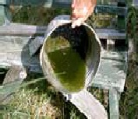

**DRAIN: water from garbage cans, house gutters, pool covers,**

**coolers, toys, flower pots or any other containers**

**where sprinkler or rain water has collected.**

**DISCARD: Old tires, drums, bottles, cans, pots and pans,**

**broken appliances and other items that aren't being used.**

**EMPTY and CLEAN: Birdbaths and pet's water bowls at least once or twice a week.**

**PROTECT: Boats and vehicles from rain with tarps that don't accumulate water.**

**MAINTAIN: The water balance (pool chemistry) of swimming pools.**

**Empty plastic swimming pools when not in use.**

Don’t forget to

drainandcover

**COVER your skin with clothing and use mosquito repellent.**

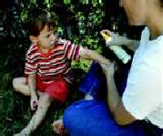

**CLOTHING: If you must be outside when mosquitoes are active, cover up.**

**Wear shoes, socks, long pants, and long sleeves.**

**REPELLENT: Apply mosquito repellent to bare skin and clothing. Always use repellents according to the label. Repellents with DEET, picaridin, oil of lemon eucalyptus, and IR3535 are effective. Use mosquito netting to protect children younger than 2 months.**

**COVER doors and windows with screens to keep mosquitoes out.**

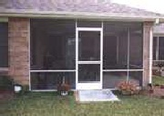

**Repellent Information**

* **Always read label directions carefully for the approved usage before applying a repellent to skin. Some repellents are not suitable for children.**
* **Products with concentrations of up to 30 percent DEET are generally recommended. Other EPA-approved repellents contain picaridin, oil of lemon eucalyptus, or IR3535. These products are generally available at local pharmacies. Look for active ingredients to be listed on the product label.**
* **Apply insect repellent to exposed skin or onto clothing, but not under clothing.**
* **In protecting children, read label instructions to be sure the repellent is age-appropriate. According to the CDC, mosquito repellents containing oil of lemon eucalyptus should not be used on children under the age of 3 years. DEET is not recommended on children younger than 2 months old.**
* **Infants should be kept indoors or mosquito netting should be used over carriers when mosquitoes are present.**
* **If additional protection is necessary, apply a permethrin repellent directly to your clothing. Again, always follow the manufacturer's directions.**